To compare the foaming capacity of different samples of soap.

Aim:

“To compare the foaming capacity of different samples of soap”.
Variables:
- Select soap (A or B or C or D).
- RESET button.
Procedure of soap A:
Step 1:
Apparatus:
- 4 beakers
- Weight balance
- 4 glass rods
- Plate
- White paper
Chemicals:
1. SOAP A
Procedure:
- Drag and drop white paper on the electric balance.
- The electric balance shows 0.6g weight on the display.
- Click on the TARE button to reset the weight to 0.
- Drag and drop soap A from the plate to the paper placed in the weight balance.
- The weight balance will show the weight (1g).
- Drag soap A from the weight balance and drop it to the beaker A.
- Click the glass rod placed in the beaker for mixing.
- Repeat the same procedure on all soap then Click on the NEXT button to continue.
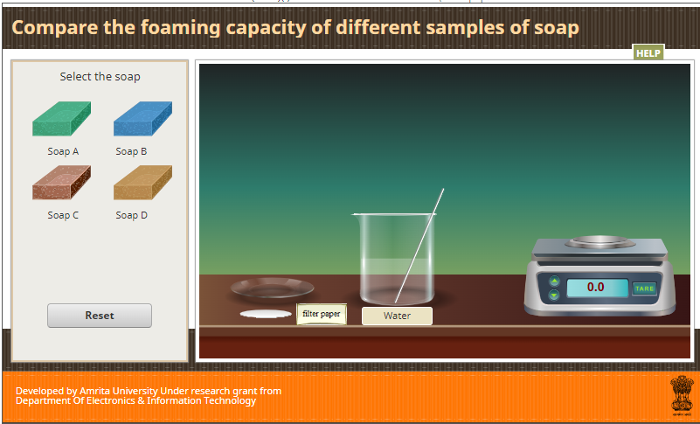
Step 2:
Variables:
- Select Solutions A, or B, or C, or D.
- Reset
Apparatus:
- 4 Test Tubes
- 1 Beaker
- 2 Dropper
- 1 Bottle
- 2 Stand
Procedure:
- Drag the dropper 1 to take 1ML of solution and drop to the test tube A.
- Drag dropper 2 to take 5ML of distilled water from the bottle and drop the water in the same test tube.
- Continue the step 3 until all the solutions are selected.
- Next button is visible after completing above steps
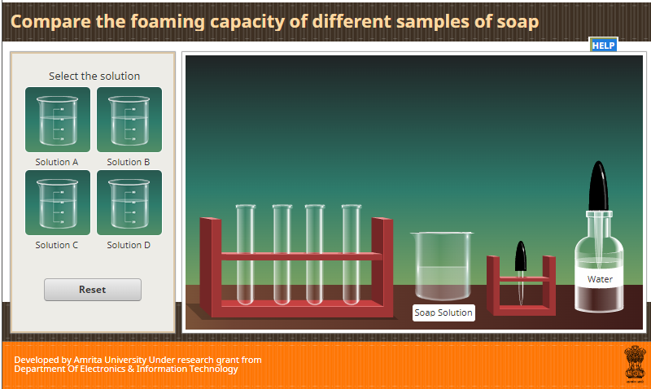
Step 3:
Apparatus:
- 4 Test Tubes
- Scale.
- Test tube stand.
Procedure:
- Drag the test tube labelled as tube A and drop to the right top corner.
- Then it is Automatically shake ten times.
- While shaking place thumb on its mouth.
- By shaking the test tube, the foam to be formed (The length of foam shows randomly).
- Drag and drop the test tube to measure the foam of each test tube.
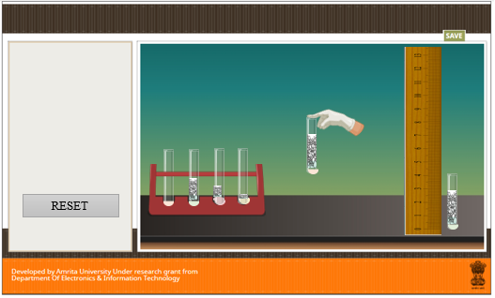

Procedure of soap B:
- Same as Procedure of soap A.
Procedure of soap C:
- Same as Procedure of soap A.
Procedure of soap D:
- Same as Procedure of soap A.
Inference
The different samples have different foaming capacity and the soap with highest foaming capacity have high cleansing capacity.

